GDAPS2 – Practice Exercise

Graph Searching - DFS

Objective
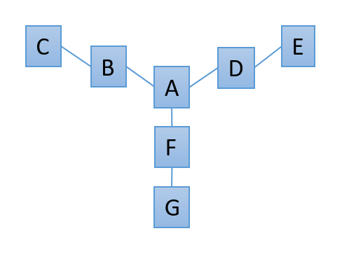
Practice searching through a graph using a Depth First Search in a new console app.

Details
You will be creating another Graph class for this exercise; however, unlike last time, this graph will be using an Adjacency Matrix to store its edge information. For this exercise, you'll be setting up the graph as shown to the right.

Vertex Class
It needs at least one field – a string “Name” – along with a get property. The constructor should take the name of the vertex.

Graph Class
Set up an adjacency matrix. In addition to this adjacency structure (a 2D array), you will also need a Dictionary<String, Vertex> and a List<Vertex>. These should both contain the exact same vertex objects (do not make each object twice!)

The Dictionary lets you get a Vertex by its name – great for finding a specific vertex.
The List lets you get a Vertex by its index – useful after searching the adjacency matrix.

You’ll also need to create all of the relationships for your data. This time, however, you’ll do that by filling in the adjacency matrix. Zero (or false) means no relationship. One (or true) means the vertices are connected.

You may even find it useful to create a helper method that takes the name of two vertices and sets their adjacency info appropriately (A→B and B→A)

Tracking the Search
You’ll need to implement a way to track which nodes you’ve already visited during this particular search. There are multiple ways of doing this. Below are two possibilities; choose one of them to implement:

- Create an array of Booleans in your Graph class called “visited”. Its length should be equal to the number of vertices in your graph. Before searching, you would need to reset all of the values to false. As nodes are visited during a particular search, you would flip the Booleans to true.

- Store the “visited” boolean in each vertex itself. This requires adding a second field (and get/set property) to the Vertex class.

Methods
Implement the following methods in your Graph class, along with any helper methods you feel you might need.

public Graph()
- Your graph’s constructor should set up vertices and edges according to the graph on the first page of this document.
- Make each Vertex object in a separate variable, then add that variable to both the Dictionary (the key is the vertex’s name) and the List.
- When adding to the list, the order should match your adjacency matrix.
- Remember: You need to add the SAME object to both data structures.
- Potentially create the visited Boolean array here (if you chose option 1 above).

void Reset()
- Reset your “visited” information to false.
- This may differ depending on your particular implementation

Vertex GetAdjacentUnvisited(String name)
- This will first find a specified vertex (if the name is valid).
- Instead of returning THAT vertex, it will return another vertex that is both adjacent to the specified vertex and currently unvisited.
- If there are no vertices that match (for example, all adjacent vertices are already visited), it should return null.

void DepthFirst(String name)
- This method takes the name of a vertex to use as a starting point and will search through the graph, printing out each vertex in a depth-first order.
  - For this exercise, do this iteratively, not recursively.

- Start by checking to see if the name is valid.
  - If not, print out an error message and return.
- Reset all vertices
- Create a Stack<Vertex> to keep track of the current vertex

- Get the current vertex (specified by the parameter of this method)
  - Print out its name, add it to the stack, mark it as visited

- Keep looping while there is something on the stack:

  - Get an adjacent & unvisited vertex (to the vert on top of the stack)
    - Use the stack’s Peek() method to get but not remove it

  - If you didn’t find one:
    - We’re done with this vertex, so pop it off the stack

  - If you did find one:
    - Print out its name, add it to the stack, mark it as visited

Main Method
Create the Graph object, then perform a Depth First Search starting on any vertex you wish. You should see all of the vertices being printed out in a depth-first order.
What would a valid depth-first order be for this particular graph? Remember that the search will go all the way down each branch before backing up and choosing another. Below are some samples, though the exact branch your code takes might differ slightly.

Starting at C: C, B, A, D, E, F, G
Starting at E: E, D, A, B, C, F, G
Starting at A: A, B, C, D, E, F, G

Finished?
Make sure you follow the coding standards for all code you create.
Demonstrate your code to the instructor or TA and show them the code.

